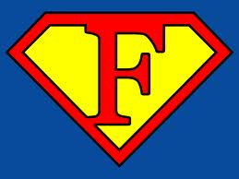

**School Parliament meeting - October 14th , 2014 meeting**

Program:

1. Welcome to our school, presentations Matěj Pospisil

2. Newly- elected SP members - signing the contracts headmistress

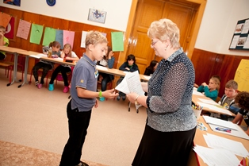

Celebratory toast

3. Socialization game, warm - up Civics teacher Vera Nemcova



4. a) Workshops - planning: events and projects for new school year 2014/15 Vera Nemcova

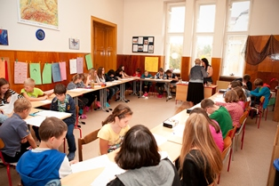

5. Workshops Summary Group leaders

6. Discussion

7. Goodbye